For each of the following linear relationships:
- Write the rule
- Draw the graph
Question 1
x | -2 | -1 | 0 | 1 | 2 | 3 | 4
y | 0 | 2 | 4 | 6 | 8 | 10 | 12
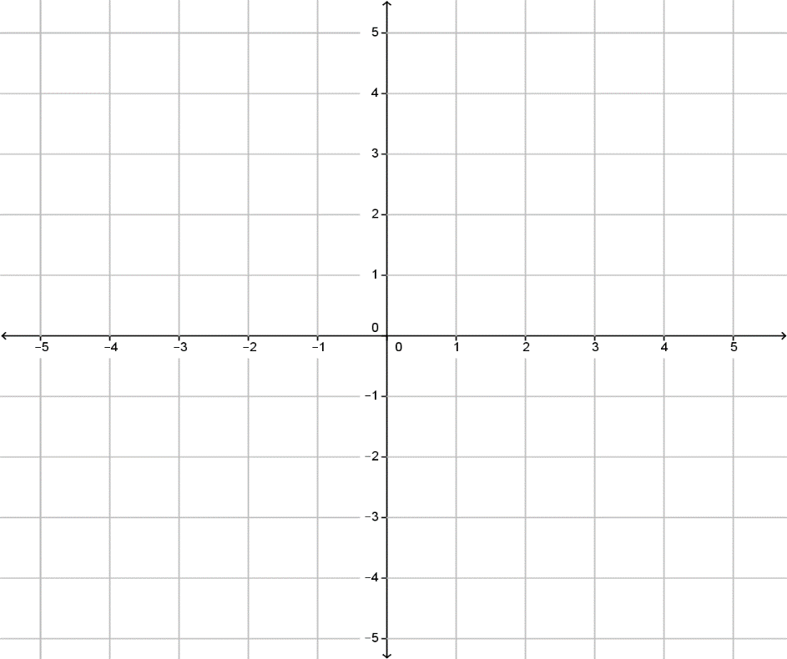
y
$$y$$
$$x$$
Gradient =
y- intercept =
Therefore the rule is
y = ____ x + _____

x

Question 2
x | -2 | -1 | 0 | 1 | 2 | 3 | 4
y | -4 | -3 | -2 | -1 | 0 | 1 | 2

y
$$y$$
$$x$$
Gradient =
y- intercept =
Therefore the rule is
y = ____ x + _____

x

Q6 On the graph below, draw the following equations.

y = 4x – 1
$$y$$
$$x$$
y

t = 0.5g +2

s = -2f + 3
x

Q7 On the graph below, draw the following equations.

y = -x
y
x
$$y$$
$$x$$
y = 3x
r = 2d -4

